Case study – Project schedule using PDM

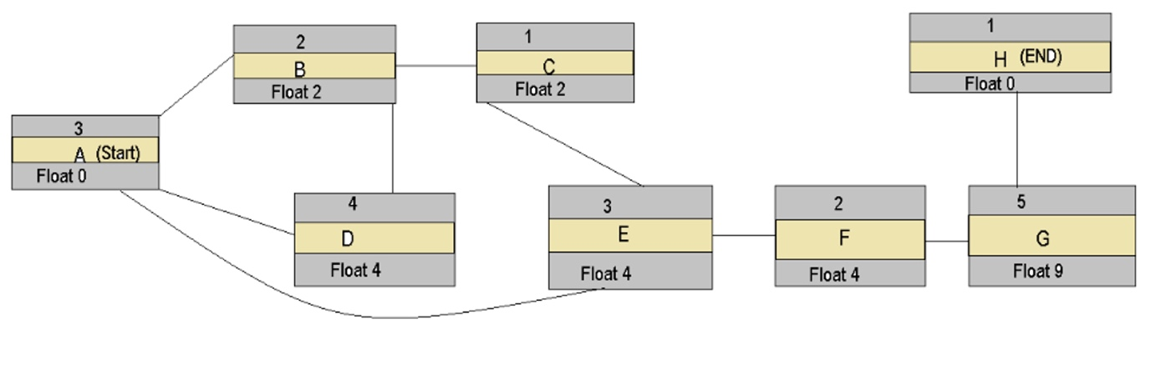

1. When is the delivery date:

Project delivery date is 21 weeks

1. Specify the float per task: